Individual Pathways
Activity 4.3
Investigating chemical patterns further

- Match the drawings of the following molecules (A to E) to the molecular formulae listed below.
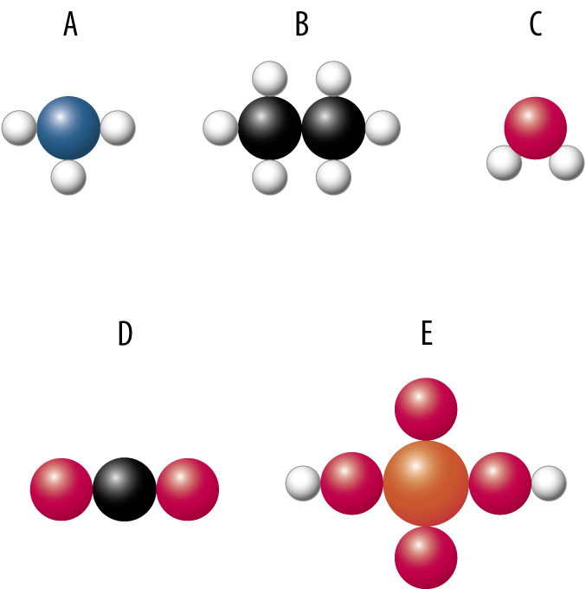
- CO₂ ……….
- H₂SO₄ ………
- H₂O………
- NH₃………
- C₂H₆………

- The following diagram shows the electron dot structure of four elements.

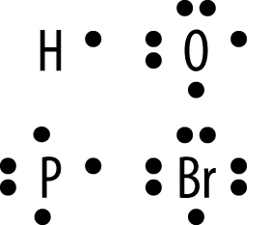
- The dots represent electrons. Where in each atom are these electrons located? ..................................................
- Draw electron dot diagrams of the following molecules.
- Phosphine (PH₃) | (ii) Hydrogen bromide (HBr)
- Water (H₂O) | (iv) Phosphorus tribromide (PBr₃)

- The following table provides the atomic radius of elements in period 3.
Z | 11 | 12 | 13 | 14 | 15 | 16 | 17 | 18
Atomic radius (picometres) | 186 | 160 | 143 | 116 | 110 | 102 | 99 | 71

- Draw a column graph of this data.

- Explain the trend in atomic radius across period 3.
……………………………………………………………………………………………………………………………………………………………………………………………………

- For each set identify the element that does not fit in this group. Give a reason for your answer.
- Zn, Au, Na, Ag, W, V, Os ......................................................................................................
- K , Cs, Ir, Mn, I, Fe, Li, Fr .....................................................................................................
- Br, O, F, Kr, He, N, Ne ..........................................................................................................
- Ru, Nd, Rh, Co, Zr, Ti ............................................................................................................

- Four silvery metals (P,Q, R and S) are each placed in separate tubes that contain equal volumes of sulfuric acid. The drawing shows the appearance of the tubes and contents after four minutes.
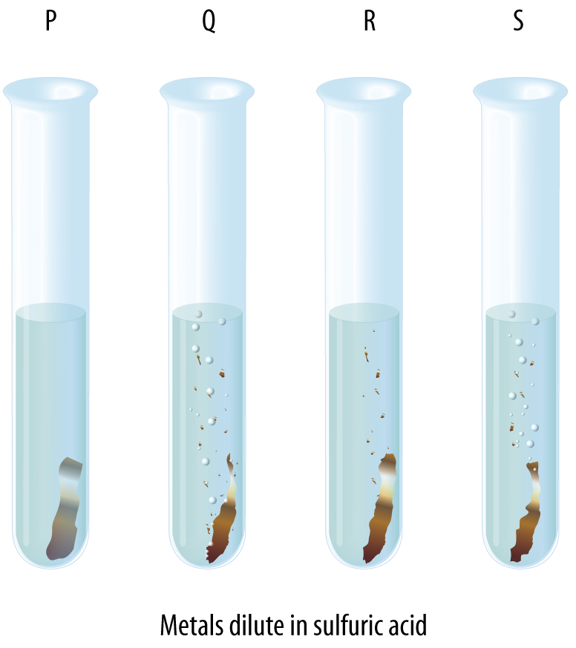

- Name the gas being evolved in some of the tubes. ........................................................
- The aim is to compare the reactivity of the four metals. What variables must be controlled in this experiment?
……………………………………………………………………………………………….......
(c) In random order, the metals are zinc, tin, magnesium and lead. Identify which metal is in each tube.
…………………………………………………………………………………………………

- Write balanced symbolic equations for each of the following reactions. In each case, state whether the products are ionically or covalently bonded
- Hydrogen gas reacts with oxygen gas to form water.
.......................................................................................................................................................
- Heated potassium solid reacts with chlorine gas to form crystals of potassium chloride.
......................................................................................................................................................
- Carbon monoxide gas reacts with oxygen gas to form carbon dioxide gas.
.......................................................................................................................................................

